Chapter 15, Solution 39.

- 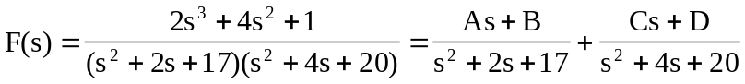

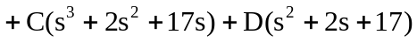
Equating coefficients :
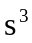: 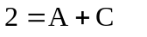
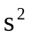: 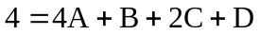
: 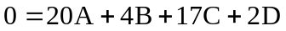
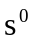: 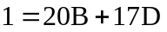

Solving these equations (Matlab works well with 4 unknowns),
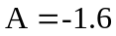, 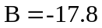, 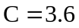, 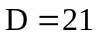

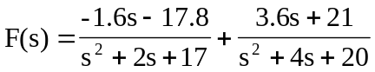
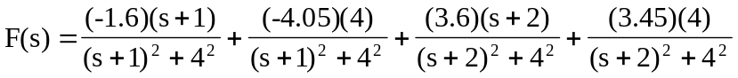

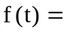
[]u(t)

- 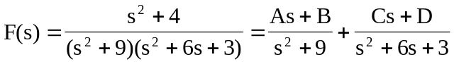

Equating coefficients :
: 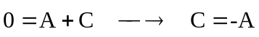
: 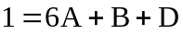
:
: 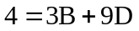

Solving these equations,
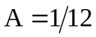, 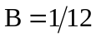, 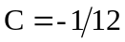, 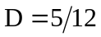

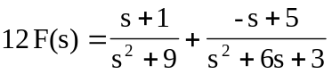

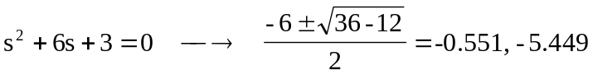

Let 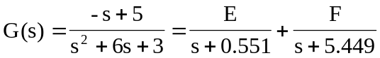

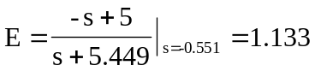
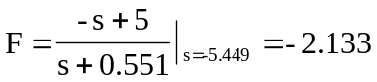

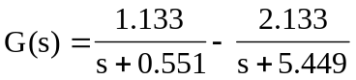

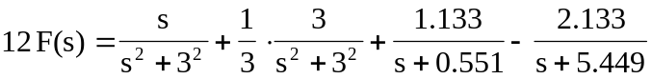

[]u(t)

